OUT PUTS OF SQL OF DATA ANALYSIS

* Use SELECT, WHERE, ORDER BY, GROUP BY
* Output of select and where:

* Output of order by:

* Output of group by:

* Use JOINS (INNER, LEFT, RIGHT)
* Output of inner join:

* Output of left join:

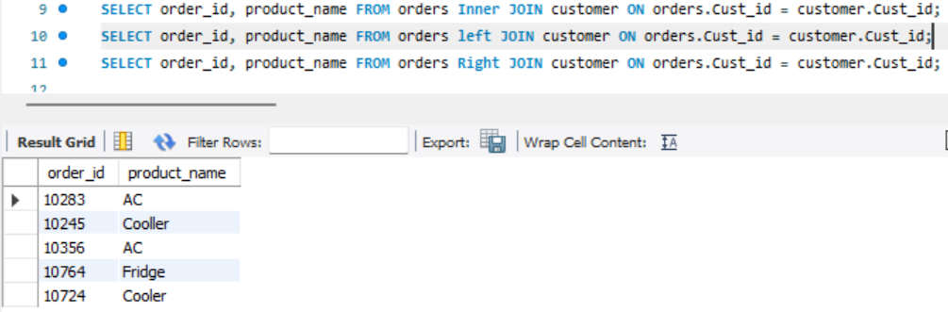

* Output of right join:

* Output of subqueries and aggregate functions of (Sum, Avg ):
* Output of Sum:

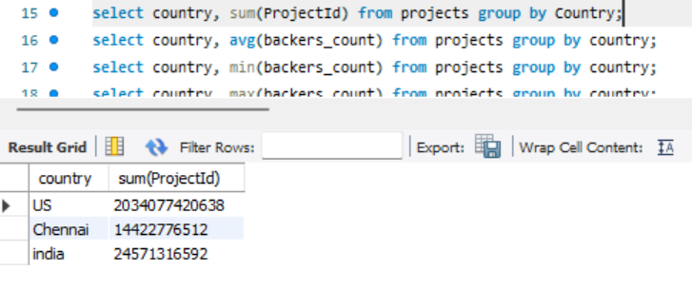

* Output of Average:

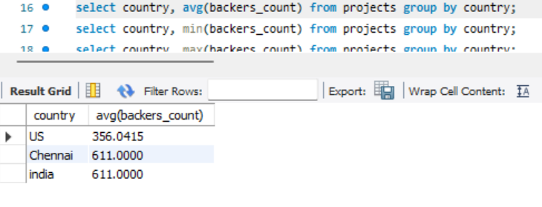

* Output of Create views for analysis :

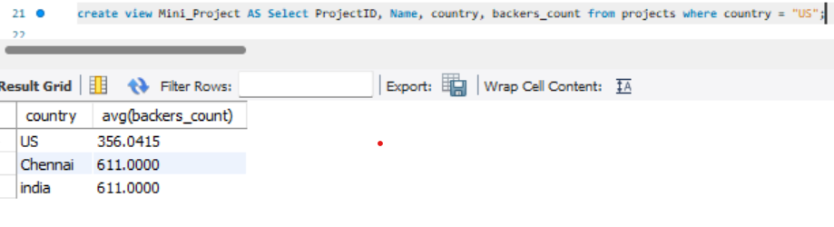

* Output of Optimize queries with indexes:

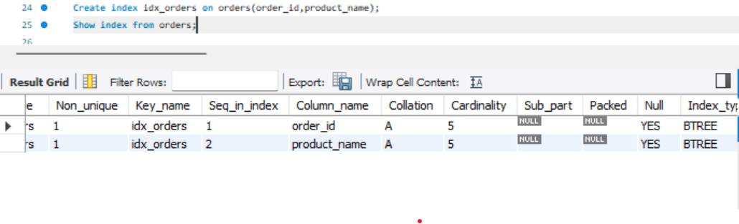

* Write subqueries

